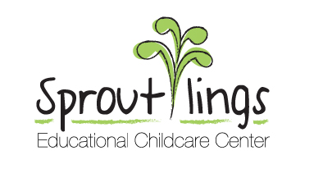
Holiday Closing Dates for 2019

New Year’s Day Tuesday, January 1
Martin Luther King Jr. Day Monday, January 21
Staff Training Day Friday, February 15
President’s Day Monday, February 18
Good Friday Friday, April 19
Memorial Day Monday, May 27
PreK 4 Graduation Friday, June 14th center closes at 4:30pm
July 3rd Wednesday, July 3, center closes at 4:00pm
Independence Day Thursday, July 4
Staff Training Friday, August 30th
Labor Day Monday, September 2
Day before Thanksgiving Wednesday, November 27, center closes at 4:00 pm
Thanksgiving Weekend Thursday, November 28 and Friday November 29
Christmas Eve Tuesday, December 24
Christmas Day Wednesday, December 25
New Year’s Eve Tuesday, December 31st
New Year’s Day (2020) Wednesday, January 1st

